14、Ultrasonic obstacle avoidance

**Follow the steps to splice the building blocks ：**

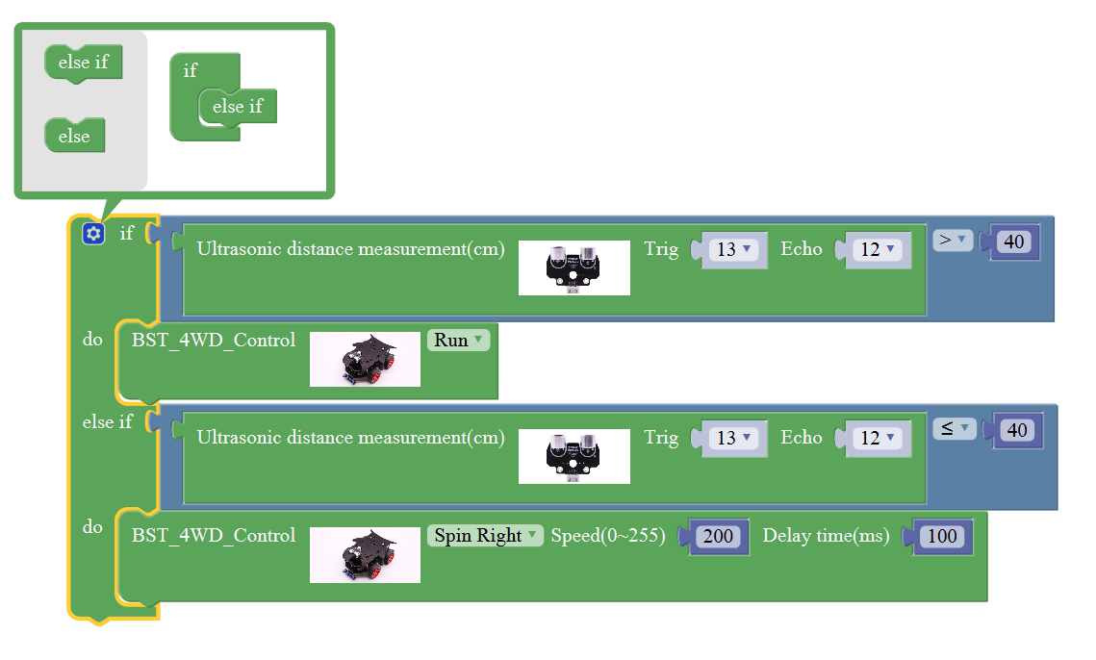

**1、Experimental building blocks :**

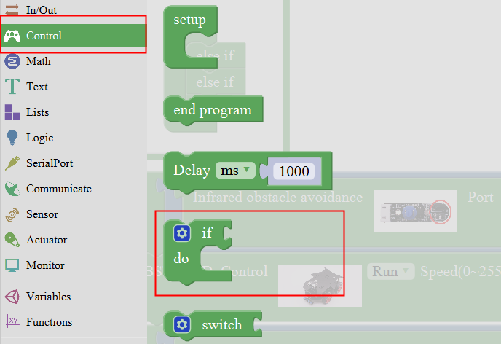

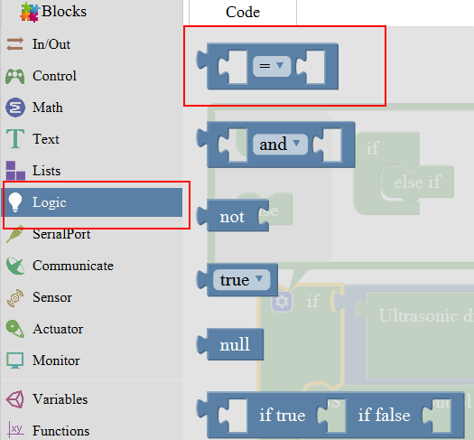

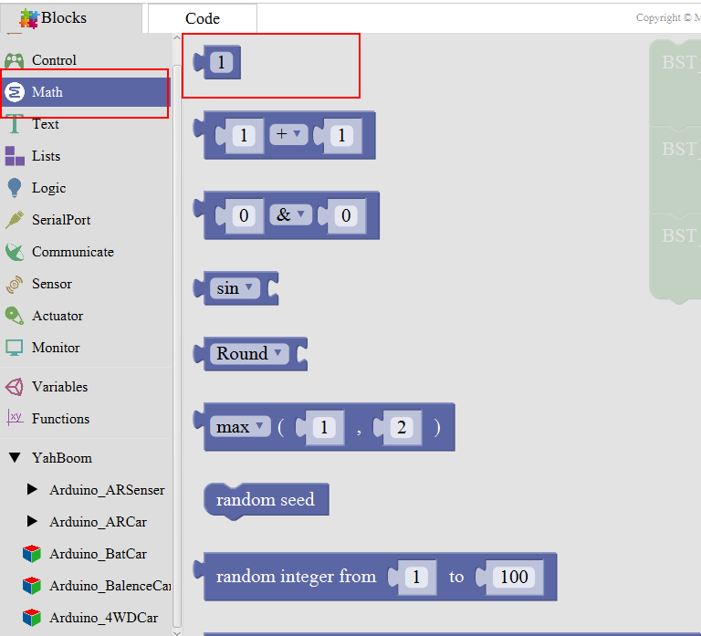

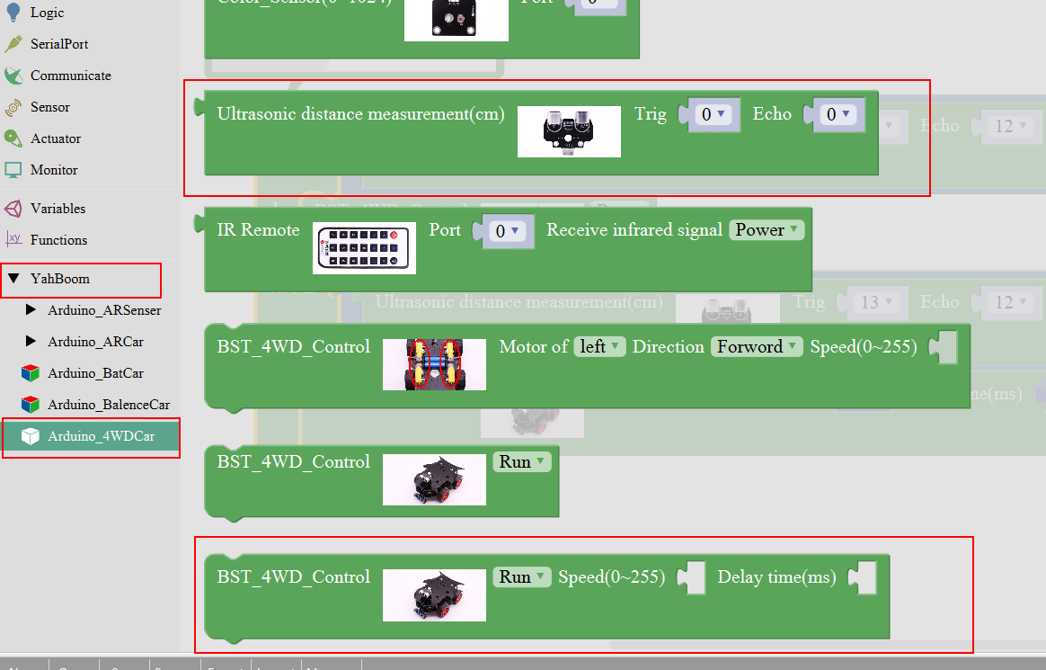

Note:

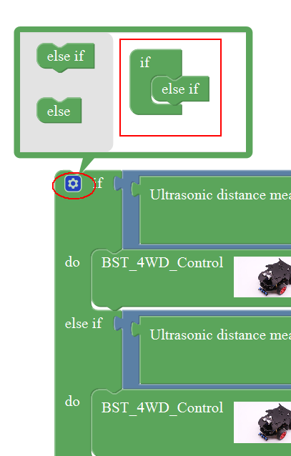

**2、Experimental verification：**

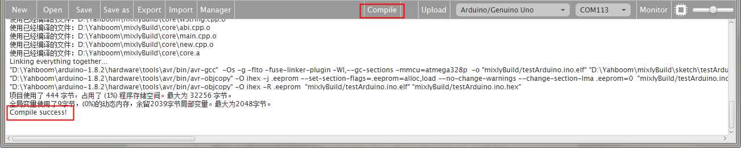

a、After splicing, select the compile button above the picture, wait for the completion of the compiler, the following box will prompt the compiler successfully, if prompt the compile failure is the problem of building block splicing.

b、After compiled , select **Arduino/Genuino Uno** follow the picture,

selects the serial number of the corresponding board.

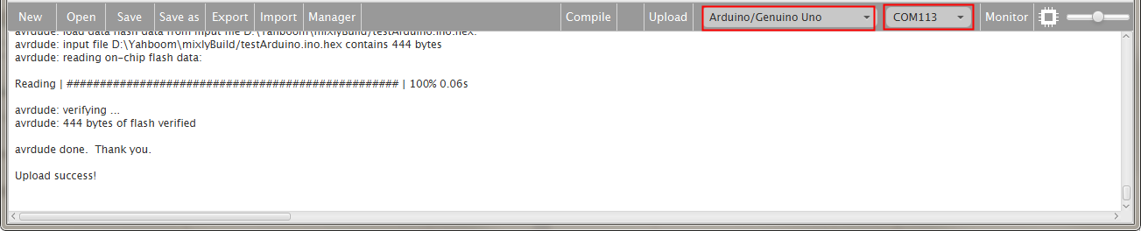

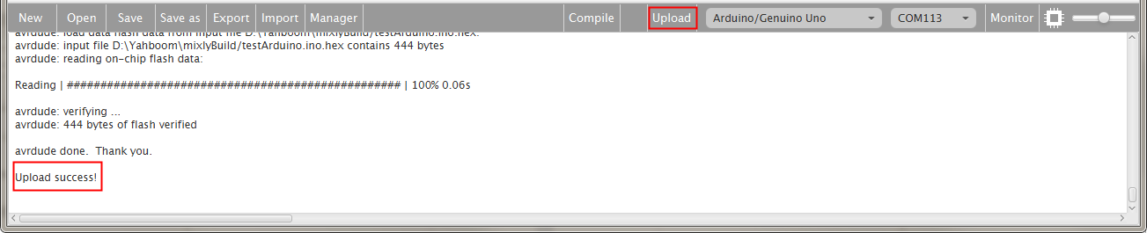

c、After configured,select the upload button above the picture, wait for the following box prompt the upload successfully. The car is placed in the obstacle avoidance area, turn on the power, the car forward, obstacle distance is less than or equal to 40cm, the car still continue testing, right for a while, the distance is greater than 40cm, the car has always been ahead, waiting for a distance of less than 40cm, continue the previous steps.